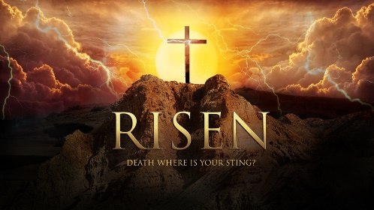
The Promise!

We often forget that Jesus was Jewish and the vast majority of ALL the first Christians were also Jewish??? What… How?
Daniel 2: 44 – 45:

SHOW ME A SIGN (Matthew 12: 38 – 42)
1)

2)

Jonah Chapter 2 and 3:

Eusebius “Proof of the Gospel”

Valley Church as we look closely at the resurrection we must CLEARLY see:
First Easter

You are the “SIGN OF JONAH!”

The Promise!

We often forget that Jesus was Jewish and the vast majority of ALL the first Christians were also Jewish??? What… How?
Daniel 2: 44 – 45:

SHOW ME A SIGN (Matthew 12: 38 – 42)
1)

2)

Jonah Chapter 2 and 3:

Eusebius “Proof of the Gospel”

Valley Church as we look closely at the resurrection we must CLEARLY see:
First Easter

You are the “SIGN OF JONAH!”

